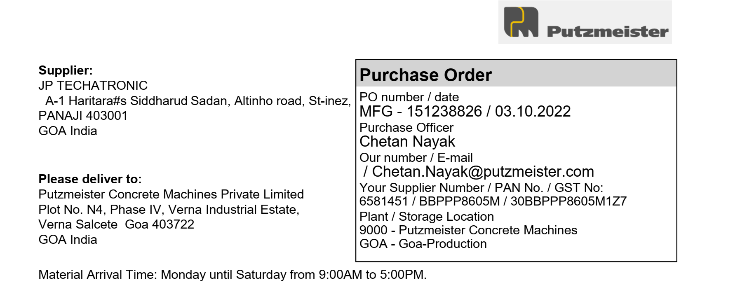

|  |  |  |  |  |  |  |
| --- | --- | --- | --- | --- | --- | --- |
| **Sr. No** | **Material** | **Description** | **Quantity** | **Unit** | **Price Per Unit** | **Net Price (INR)** |
| 1 | 615863 | Control Room Spike Board | 1 | PCS | 600 | 600 |
|  |  |  |  | CGST | 9% | 54 |
|  |  |  |  | SGST | 9% | 54 |
| Delivery Schedule |  |  |  |  |  |  |
| Date | 10.11.2022 |  |  |  |  |  |
| 2 | 719381 | Monochrome laserjet printer CanonLBP6030BJ | 10 | PCS | 8299 | 82990 |
|  |  |  |  | CGST | 9% | 7469.1 |
|  |  |  |  | SGST | 9% | 7469.1 |
| Delivery Schedule |  |  |  |  |  |  |
| Date | 05.11.2022 |  |  |  |  |  |
|  |  |  |  | Basic Total | | 83590 |
|  |  |  |  | Central GST | | 7523.1 |
|  |  |  |  | State GST | | 7523.1 |
|  |  |  |  | **Total In INR** | | **98636.2** |
| Amount In Words: | |  |  |  |  |  |
| Ninety Eight Thousand Six Hundred Thirty Six Rupees and Twenty Paise. | | |  |  |  |  |

It is necessary to put the Putzmeister order number on every invoice.

Terms and conditions applied.



